1 September 2019 (Sun) 8.00am Asian Civilisation Museum
SPD Ability Walk & Run 2019

Registration Form

Categories | 3-km Fun Walk |  | 5-km Fun Run
 |  | Pls indicate no. of Pax. |  | Pls indicate no. of Pax
Adult | $30 |  | $38
Child (Age 5 to 12) | $15 |  | $23
Buddy Deal – 2 Adults | $56 |  | $72
Adult (Bulk Sign-up of 10 or more) | $25 |  | $33
Affiliated Partners / Past participant
Adult | $28 |  | $36
Buddy Deal – 2 Adults | $52 |  | $68

DETAILS OF MAIN PARTICIPANT

Full Name: |  | NRIC No./ FIN:
Date of Birth: |  | Gender: | Male / Female
Mailing Address: | Postal Code: ( ) | Name of Organisation:  (If Applicable)
Contact No.: | (Tel) | (Mobile)
E-mail Address: |  | T-shirt Size
Contact Person (in case of emergency) |  | Contact No.
Declaration : I and on behalf of the other participants in my group-
- confirm I am/we are registering for /participating in the SPD Ability Walk 2018 at my/our own risk and I/we shall not, to the fullest extent permitted by law, hold the Organisers responsible for any death or injury, loss or damage, sustained or suffered by me/us, howsoever arising and whether before, during or after the Walk.
- declare that all entries and information provided in this form are true and correct; and I/we agree to abide and be bound by the Rules and Regulations of the Event.
- agree for SPD to send information, news and any other form of communications relating to its programmes, services and events to me/us. I/We understand my/our right to unsubscribe from receipt of all these correspondences at any time by email sent to information@spd.org.sg.

________________________ __________________________
Signature Date
PLEASE TURN OVER TO COMPLETE THE REST OF THIS FORM.

ACKNOWLEDGEMENT SLIP (TO BE COMPLETED BY SPD STAFF)

This serves as an official acknowledgement of receipt of SPD Ability Walk Registration Form:
Full Name of Main Participant |  |  | NRIC No. / FIN
Total No. of Registrant(s) |  | Total Amount Received |  | S$
Mode of Payment | CASH / CHEQUE
Signature &  Name of SPD Staff  For enquiries on the Walk, please email to events@spd.org.sg or call 6579-0669.  Please remember to bring along this acknowledgement slip for collection of goodie bag. |  |  | Date
DETAILS OF ADDITIONAL REGISTRANTS

NRIC/FIN: |  | Name of Registrant 2:
Date of Birth: |  | ^Gender: M / F | Relationship to main participant:
Contact No.: |  | E-mail Address: |  |  | T-shirt Size:

NRIC/FIN: |  | Name of Registrant 3:
Date of Birth: |  | ^Gender: M / F | Relationship to main participant:
Contact No.: |  | E-mail Address: |  |  | T-shirt Size:

NRIC/FIN: |  | Name of Registrant 4:
Date of Birth: |  | ^Gender: M / F | Relationship to main participant:
Contact No.: |  | E-mail Address: |  |  | T-shirt Size:
^ Please circle the appropriate response
PAYMENT DETAILS

Total No. of Registrant(s) |  | Total Amount Payable | S$

Please tick (√) the mode of payment and provide details (if necessary):
 | Cash^
 | Cheque* (Payable to “SPD”) | Bank Name: | Cheque No.:

^ Please do not send cash in the mail. For cash payment, please visit
SPD Ability Centre, 2 Peng Nguan Street, Singapore 168955
From 9am to 5pm on weekdays (i.e. Monday to Friday, except Public Holidays)

* Please mail the cheque to the above address.

ADULT T-SHIRT SIZES KIDS T-SHIRT SIZES

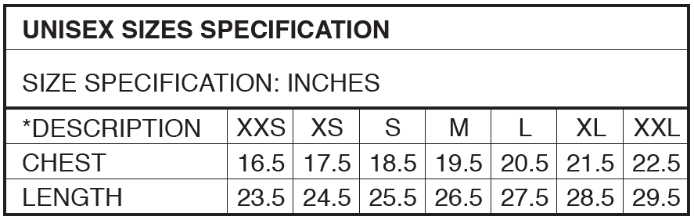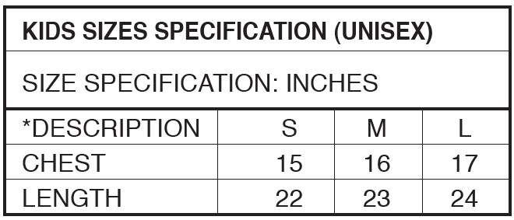

Important Rules & Regulations (For details, please visit www.spd.org.sg)

Registration is deemed complete when payment is successfully made and accompanied by a duly completed registration form. Registration fees are non-refundable and non-transferrable. SPD reserves the right to limit and/or refuse registration/entry without assigning any reason or giving notice.

- Participants must be 5 years old and above. Participants below 12 years old must be accompanied for the Walk and be registered by their parent(s)/an adult.
- SPD reserves the right to cancel or postpone the Event at any time without prior notice, in which case SPD will make reasonable efforts to inform the Participant of the cancellation or postponement prior to the date of the Event.
- SPD reserves the right to use any photographs (including those of participants), voice/video recordings or any other media records of the Event, for any legitimate purpose including commercial advertising and distribution to the sponsors.
- All personal data provided by the participants shall only be used by SPD and for the purposes of sending communication materials to the participants. By signing up for the Event and providing any information, personal or otherwise, the participant is deemed to have given permission to SPD to use such information for marketing, statistical and planning purposes.
- SPD reserves the right to modify or substitute any of the rules and regulations from time to time as SPD deems fit.
- Participants who have registered under the discounted ActiveSG member's rates will be required to produce their ActiveSG virtual card for on-site verification during the collection of the event goodie bag. Those unable to produce the ActiveSG virtual card for verification will have to top up the fees according to regular rates.

