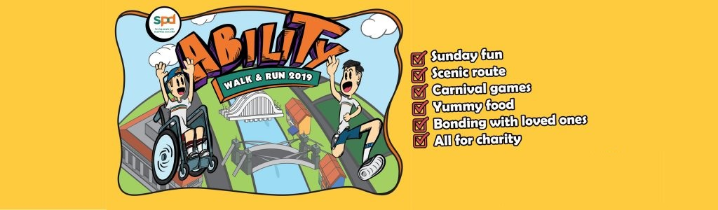

SPD ABILITY WALK & RUN 2019
LETTER OF AUTHORISATION FOR GOODIE BAG COLLECTION

I, __________________________ (Name of Participant), __________________ (#NRIC / FIN No.) hereby authorised _________________________________________ (Name of Representative), _____________________ (#NRIC / FIN No.) to collect the t-shirt & goodie bag on my behalf.

I am fully aware that my authorised representative will need to bring along the following documents for the t-shirt & goodie bag collection:

- Photocopy/Scanned image of participant’s NRIC / Foreign Identification Card
- Signed Copy of Letter of Authorisation (LOA)
- Authorised representative’s NRIC / Foreign Identification Card

Yours sincerely

_________________________
Signature of Participant / Date

# Do not give your full NRIC/FIN number, just the last 3 digits & checksum (i.e. alphabet reference) will do.

